  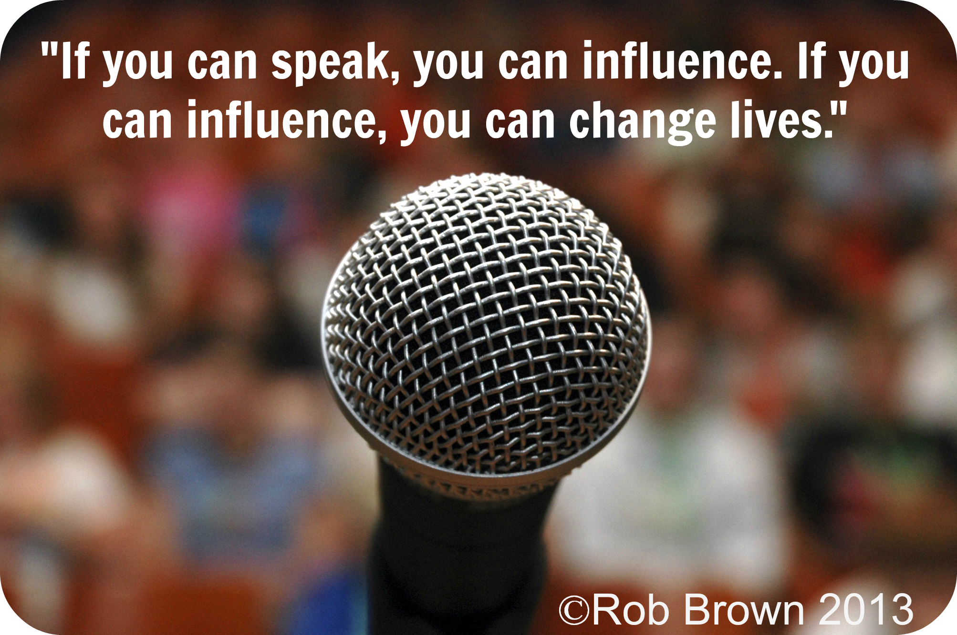
    - IntErnational Speech Contest
  February 17th 2016
    - eVALUATION Contest
  February 24th 2016
  Wednesday @ NOON
  CANYON PARK ECHOES TOASTMASTER CLUB
  Cordially Invites
  Toastmasters, families, friends and non-Toastmasters
  Judges, Contestants, Toastmaster & Sergeant at Arms, please report in no later than 11:30 am
  Early Arrival Perks: Parking near the building
  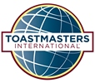
  Canyon park echoes
  Area 54, Division E, District 2
  Registration Starts @ 11:30 am
  Contest begins
  @ Noon
  Venue:
  RE/MAX NOrthWEST 1909 214TH St SE #205 BOTHeLL, WA 98021
  For Directions Call @ 425-481-8888 see BACK for map
  Plea
  V
  RSVP
  Vivek Garg / nELISHA MONTEIRO
  vgarg30@gmail.com
  nelisha_monteiro@yahoo.com
  @CParkEchoes

