

Canyon Park Echoes Toastmasters

Mentor/Mentee Handbook

Table of Contents

1. Responsibilities of Mentor and Mentee
2. Club Culture
3. Introducing the Toastmasters Manuals
4. Using Easy Speak
5. Toastmaster Role Checklist
7. General Evaluator Role Checklist
8. How to Print Weekly Agenda and Upcoming Schedule
9. All those Roles? What to do!

Responsibilities of Mentor and Mentee

As a Mentor, I will:

- Review this handbook with my mentee
- Listen to my mentee’s first 3 speeches (or as agreed upon) ahead of time and make suggestions
- Teach my mentee how to become familiar with Easy Speak
- Monitor my mentee’s upcoming roles and remind them of their duties

__________________________________ ____________________________________
Sign Date

As a Mentee, I will:

- Review this handbook
- Have my mentor listen to and review my first 3 speeches (or as agreed upon) before I give them
- Become familiar with Easy Speak to communicate with the club

__________________________________ ____________________________________
Sign Date
Club Culture: Every club has a distinct culture

Toastmasters is a worldwide organization and, just as language and customs differ from country to country, cultures will vary from club to club. Canyon Park Echoes (CPE) started as a closed corporate club for Panasonic. However, it is now an ‘open club’ which means it is open to all who are interested in the Toastmasters program. The CPE culture is one of ease and welcome. We are a family of sorts and visitors are welcomed as we would a guest in our own home.

CPE uses a program called Easy-Speak to assign upcoming roles. On Easy-Speak, we accept/decline roles for the weeks ahead, as well as communicate our intention to attend or not attend upcoming meetings. Meetings are set 4 to 5 weeks into the future. To minimize role changes we ask that you check each week and update your ability to attend/not attend. Meeting roles may change so keeping checking the schedule weekly. We lock it to changes on Thursday of the week prior to the meeting.

There are many aspects that form our unique ‘culture’, and some are listed below.

- First is a commitment to our own personal growth and the key to that is self-responsibility:
- Fulfilling our assigned meeting roles each week, because we learn by doing
- Taking responsibility for our own learning AND seeking support when we need it

- A commitment to timely communication:
- Using Easy-Speak each week to look ahead at our assigned roles and communicate our attendance for the following 4 to 5 weeks.
- Finding a replacement if we are unable to take a role
- Resolving any issue or concern with another member directly

- A commitment to volunteerism:
- Chairing special events at the club level and beyond
- Serving on the Board at the club level when asked

- A Respect for one another:
- Listening attentively when others speak
- Giving thoughtful evaluations to the speakers each week
- Fill out your speech info and introduction on Easy-Speak for the Toastmaster
- Snack Master tries to bring food that is ‘quiet’
- Arrive early to meetings to avoid disruptions (especially true if you have a role)

Easy Speak is a very important part of the CPE culture. Our communication, or failure to communicate on Easy Speak, directly impacts other members. By using this tool, we save other members time and added effort, and we keep our inboxes just a little lighter.
Introducing the Toastmaster Manuals

The two manuals (Competent Communicator & Competent Leadership) work hand-in-hand. Write your name on the cover of your manuals so they’ll be easily identified. We all have the same manuals, so they are easily confused.

Competent Communicator (CC) Manual
There are 10 speeches, or projects. Each focuses on something specific and explains how to do it.
- The Ice Breaker speech is first, and it’s about you. Pick 1 or 2 aspects of your life to talk about, rather than squeeze your entire life into a few minutes.
- Have your mentor listen to your first 3 speeches before you give them to the group.
- Before the meeting, give your manual to your evaluator.
- When you finish a project, write the date in the Project Completion Record on page 85. This way, you’ll know what you have left to do, and the VP of Education will know what you’ve done.
- If you give 1 speech a month, you’ll complete the CC manual in 10 months.
Competent Leadership (CL) Manual (Note: Mentor, the notes below reflect the newer version.)

Each project helps you learn a particular leadership skill as you take a role.

- You get credit for every role in a meeting. You can read about each role in the CC manual (pg 67). Practice what you’re going to briefly say when your role is introduced.
- You don’t need to do every item under a project to complete the project. (ex. - Project 1: “Complete 3 of 4”)
- You don’t need to do the projects in order.
- Before the meeting, decide which project you want your role to apply to, and mark that page. Ask someone in the meeting to evaluate you in that role (preferably someone without many other responsibilities). When you give your manual to your evaluator, show them where they are to write.
- When you finish a role, write the date in the Project Completion Record which is on the last page. This way, you’ll know what you have left to do, and the VP of Education will know what you’ve done.
- The Appendix of the CL Manual (page 57) gives information and tips about the more advanced projects, #6 through #10. Don’t worry about that now – just know there’s more help for you when you’re ready.

Using Easy-Speak

Log in and Main Introduction
- You should have received an email from EasySpeak.org with your username and password. If not, contact your Vice President of Education.
- Bookmark the home page (http://canyonparkechoes.easy-speak.org ).
- Review the options you have on the left side (My Participation, Meeting on xx/xx/16).
- When you are assigned the role of Toastmaster, you will have more options.
- Review the tabs at the top (Home, Meetings, My Participation, My Communication, This Club, Go to…, Help Options, Profile, Logout).
- Select Help Options>Easy-Speak Videos to become familiar with Easy-Speak.
- Explore! It’s the only way to learn about the different options.

First Steps
- Select Profile>Profile and update your profile with your information (phone number, picture, etc). Please add a contact phone. It will ONLY be used for TM purposes.
- Select Meetings>Meeting on xx/Month to see the next meeting. In the meeting agenda chose: I WILL / WILL NOT attend this meeting .
- Select My Participation>Sign Up for Meeting Roles to take an open role for an upcoming meeting.
- If you are ever assigned a role that you can’t fill, it is your responsibility to find a replacement person and have them accept it from Easy-Speak.
- Usually meetings are scheduled at least two months ahead for you to indicate whether you will attend or not. If you will be out for an extended period of time, please inform your VP of Education.

Next Steps
- Select My Participation>View my Speech Progress to add a manual such as your Competent Communicator. You can also set goals for yourself, request a speech and view your progress.
- Select My Participation>View My CL Progress to set a Leadership goal.
- Select This Club>User List to view other members of the club and other resources.

Special Powers (and Responsibilities) on Easy-Speak as Toastmaster
When you are in the Toastmaster role for a specific week, you have more options.
- On the left side, you can assign Speeches, and Send Meeting Emails.
- Assign vacant roles by selecting members on the agenda page for that day.
- IMPORTANT: Our club uses a template to produce the agenda. See “TM Role Checklist” or “How to Print Weekly Agenda and Upcoming Schedule” later in this handbook.

Toastmaster Role Checklist

Pre-Meeting
At least one week prior to the meeting date, verify roles in Easy-Speak are filled. Encourage those who have not responded to do so.
Contact your Speakers and verify they have loaded their speech information and introduction into Easy-Speak (ES).
Contact the Table Topics Master to be sure they are ready for the meeting.
If you need to send an email to all members of the club you can do so with the address members-4365@toastmastersclubs.org.
If you need to replace someone or add speech information in the agenda in Easy-Speak, please consult the Help Options>Search or Help Options> FAQ in Easy-Speak. There are many great resources in there to help guide you through the process.

Day before the meeting
Print multiple copies of the agenda/upcoming schedule to bring to the meeting.
Agenda
- Use the agenda templates located on our club website (www.canyonparkechoes.wordpress.com ). The template you choose will be based on whether we will have a business meeting at the end of our regular meeting on the day you are Toastmaster. The club business meetings are on the last meeting of the month.
- Click on the Members tab and download either the document “Toastmaster Agenda Template_New Logo 09/11/12” (no business meeting) or “TM Agenda with Business Meeting Template_New Logo” (business meeting – leaves 10 minutes at end of meeting for club business).
- Change times on the agenda to match the length of the speeches and other roles
Upcoming Schedule
- Go into Easy Speak, www.easy-speak.org and log in.
- Click on the drop down menu This Club, and hover over Club Charts, scroll down to, Roles by Meeting.
- In the upper right click in the box, ‘Printable’ and then Click, GO.
- Highlight table, copy and paste to the second page of the agenda.

At the meeting
Find people to fill any last minute role vacancies.
Talk to the President or the Opening Officer to have them start the meeting.
You set the tone for the meeting, so decide how you would like to open and with what level of energy.
Be sure to encourage people to pass their Competent Leadership Manuals so they get credit for any roles they have.

General Evaluator (GE) Role Checklist

Checklist for all things a GE should do

Pre-Meeting
Go into www.canyonparkechoes.wordpress.com, Members tab and select “How TM Roles Interact” to understand the GE role and expectations. You can also get email addresses for club members in the Member Email section. (password is “letmein”)
At least one week prior to the meeting date, verify roles in Easy-Speak.
Contact your Grammarian for the Word of the Day and get that loaded into EasySpeak and emailed out to the group (the Toastmaster can email the club).
Contact the evaluators and encourage them to reach out to the speakers and find out what the speech objectives are and any other items the speakers would like to be evaluated on.
Contact your Toastmaster and let them know if all roles have been filled (okay to copy the TM on any emails sent out to your team) or if any need to be filled.
If you need to send an email to all members of the club, use our club email: members-4265@toastmastersclubs.org.
If you need to replace someone or add speech information in the agenda in Easy-Speak, please consult the Help Options>Search or Help Options> FAQ in Easy-Speak. There are many great resources in there to help guide you through the process.

Right before the meeting
Find people to fill any last minute role vacancies along with the Toastmaster.
Encourage your evaluation team members to have someone evaluate them in their Competent Leader Manual

During the meeting
Let people know what your role is during your intro speech and introduce your evaluation team. It is recommended you introduce the Grammarian first so others can start to use the Word of the Day as soon as possible.
Be sure to encourage people to pass their Competent Leadership Manuals so they get credit for any roles they have
Observe your team during the meeting for your club evaluation at the end:
Are they paying attention, avoiding distractions, do they need help with anything. Specifically pay attention to people new to the role and maybe offer to sit next to them if their mentor is not available.

How to Print Weekly Agenda and Upcoming Schedule:

The TM is responsible for printing the weekly agenda (front side) and the upcoming schedule (backside) and distributing them at the meetings. The agenda on Easy Speak can be problematic so we have chosen to use our own agenda. Below are the resources you will need to access and print agenda when you are Toastmaster.

- USE THE AGENDA ON OUR CLUB WEBSITE, NOT THE ONE ON EASY SPEAK (www.canyonparkechoes.wordpress.com). Click on the members tab and agenda templates are in the middle of the page under the heading, What to do when… The template you choose will be based on whether we will have a business meeting at the end of our regular meeting on the day you are Toastmaster. The club business meetings are on the last meeting of the month.

- Click on the Members tab and download either the document “Toastmaster Agenda Template_New Logo 09/11/12” (no business meeting) or “TM Agenda with Business Meeting Template_New Logo” (business meeting – leaves 10 minutes at end of meeting for club business).

- Change the times on the agenda to match the length of the speeches and other roles

Printing the Upcoming Schedule on the Back

- To print future meetings on back of agenda go into Easy Speak, www.easy-speak.org.

- Click on the drop down menu, This Club, and scroll down to, Club Charts, hover over and choose, Roles by Meeting.

- You will see the chart shown below:

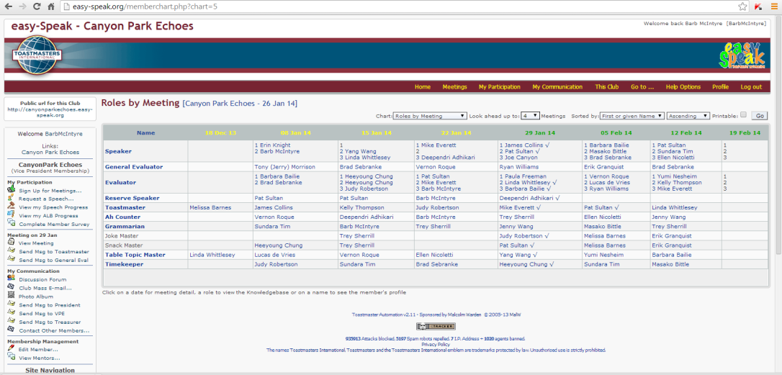

- In the upper right click in the box, Look ahead up to… and input 5 weeks, click in the box, ‘Printable’ and then Click, GO.

- The following screen will appear:

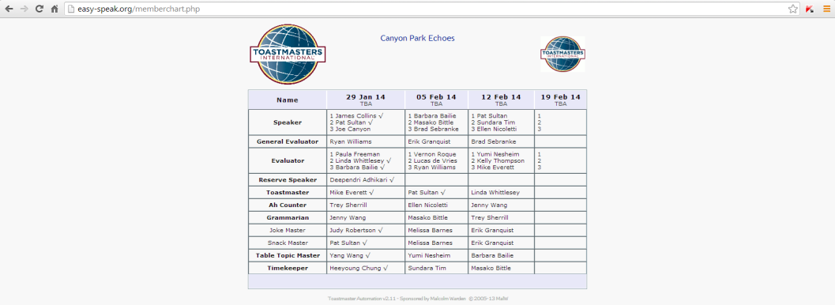

- Highlight table, copy and paste to the back of the agenda.
All those roles? What to do!

Toastmaster
- Give Competent Leadership Manual to someone to get credit for this role.
- During the week prior to the meeting, coordinate meeting with the General Evaluator.
- The Toastmaster is responsible for coordinating the Speakers, Table Topics Master, JokeMaster and SnackMaster. The GE coordinates the other roles.
- Encourage the speakers to provide a script to introduce them, including speech booklet and goal of speech. This is done on Easy-Speak.
- Arrive early to handle any last minute changes and sit near the front to get to the lectern easily.
- When introducing Speakers, stay at lectern until Speaker arrives and shake his/her hand.
- After Speakers finish, go immediately to lectern to shake his/her hand.

General Evaluator (GE)
- Give Competent Leadership Manual to someone to get credit for this role.
- During the week prior to the meeting, coordinate meeting with the Toastmaster.
- The GE is responsible for coordinating the Grammarian, Ah/Um Counter, Timer and the Evaluators.
- Remind the Evaluators to coordinate with their Speakers and to ask them what they want to focus on.
- Remind the Grammarian to send out the WOD as early as possible. – one week is good.
- If there are changes, communicate with the Toastmaster.
- Arrive early to handle any last minute changes.
- Use the General Evaluator Worksheet to take notes during meeting.
- Sit near the front since you will standing up and sitting down a lot.
- Keep agenda handy since it is easy to lose place as GE.
- When introducing Evaluators, stay at lectern until they arrive and shake his/her hand.
- After Evaluators speak, go immediately to lectern to shake his/her hand.
- When giving General Evaluation, be specific about each role as well as overall meeting evaluation. Praise and suggestions are helpful.

Speaker
- Give yourself enough time to write and practice speech.
- Provide the Toastmaster with a script to introduce you, as well as speech booklet and goal of speech. This is done on Easy-Speak.
- Give your booklet to your evaluator before meeting starts.
- When introduced, go to lectern to shake hand of Toastmaster.
- Relax and take a breath before starting to speech.
- When finished, try not to say “Thank you.” The audience should be thanking you.
- When finished, stay at podium until the Toastmaster arrives and shake his/her hand before sitting down.
Table Topics Master
- Give Competent Leadership Manual to someone to get credit for role.
- Prepare 5 table topics questions, related to a topic, theme, holiday, current event, etc.
- As meeting begins, figure out who does not have a role. Ask these people to speak. Try not to ask for volunteers.
- Keep an eye on the clock (and the Toastmaster) to not go overtime with TT.

Evaluator
- Give Competent Leadership Manual to someone to get credit for role.
- When assigned a speaker, ask them about the goal of the speech and what they would like you to pay attention to.
- Upon arrival, get the speaker’s manual from them for note taking and evaluations.
- In beginning of evaluation, let audience know the goal of the speech.
- There are different types of evaluations. One type is the sandwich style – praise, suggestion, praise.
- Make specific suggestions for improvement. They are more helpful than all praise.

Timer
- Give Competent Leadership Manual to someone to get credit for role.
- Arrive early to set up paperwork and lights. Familiarize yourself with how timer works.
- Make sure speaker can see lights.
- Before meeting, set up timer with extension cord. Make sure lights work.
- Before meeting, fill out Timer’s Sheet with speakers’ names and time limits.
- Familiarize yourself with time limits and overtime allowances of different roles.
- Give initial talk introducing role. Include testing of lights.
- When timing speeches, have only one light on at a time.
- When giving final talk, be time-sensitive. If meeting is running short on time, tell who is eligible for voting or not. If plenty of time, tell specific times of all speakers.

Grammarian
- Give Competent Leadership Manual to someone to get credit for role.
- One week early, send WOD with definition, pronunciation, and a sentence using WOD.
- Arrive early to write the above on the white board.
- At meeting, use Grammarian’s Worksheet to track grammar, WOD usage etc.
- At first speaking, let us know about WOD and what you will be looking for.
- At final speaking, let us know who used WOD and whatever else you noticed.

Ah/Um Counter
- Give Competent Leadership Manual to someone to get credit for role.
- At meeting, use Ah/Um Counter Worksheet to track filler words, etc.
- At first speaking, let us know what you will be looking for.
- At final speaking, let us know what you noticed. If meeting is running long, be brief.

SnackMaster
- Arrive early to distribute snacks.
- Bring snacks that are quiet and easy to serve and eat, and bring napkins/plates.
NOTES

